**FREELANCE SERVICES AGREEMENT (Assignment 1)**

This Freelance Services Agreement ("Agreement") is made and entered into on Start of Semester, by and between:

**Client:** CSE3CWA/CSE5006 Staff  
Address: La Trobe University  
Email: See LMS

AND

**Freelancer:** You (individual assignment)  
Address: Your Address  
Email: See LMS

**1. Scope of Work**  
The Freelancer agrees to perform the following services:

This is the first part of a larger project

Problem description:

LTU wants to build a web application that creates HTML + JS to deploy on MOODLE LMS. Current situation LMS has the capacity to used HTML5 such as carousel, tabs, accordion, modal/popup, dropdown, tooltip, progress bar, range slide, date picker, alerts, lightbook, canvas, CSS Animation (rotation), Mermaid code, etc.  
  
Part 1:

You are required to build a NextJs Application bootstrap with create-next-app.

Build your

Pages: home page, about page, etc.

Student Number will be in the top left hand corner of each page.

Header – including a Menu with either Kabab or Hamburger Menu

Themes: Dark Mode/Light Mode (or web browser themes)

Footer – including copyright, Student Name, Student Number and Date

Accessibility – must be compliance with Accessibility Standards

Cookies – Remember which menu tab you were on.

The about page:

Your name, Student number, video of how to use this website.

The homepage:

Build a website that outputs code

Output html5 code with JS and inline CSS (no CSS Classes).

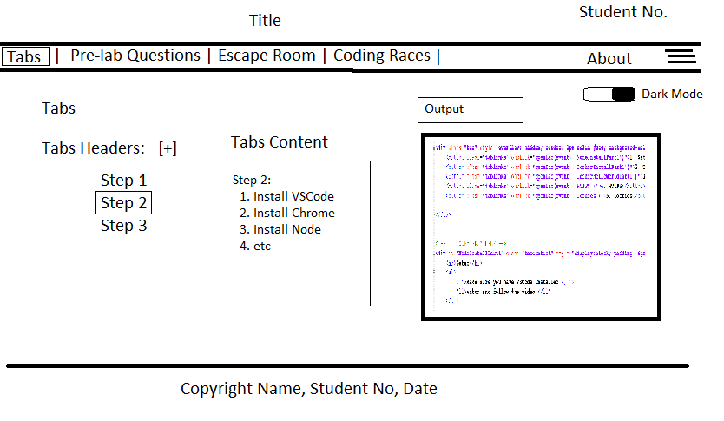

Figure 1: Screenshot of the Homepage.

Assignment 1 You are to generate the Front-end (with pages – Escape Room, Coding Races, Court Room) can revert to an empty page/not yet finish.

The output generates the HTML5 + JS code. This code should be able to be copied. If you pasted this code into a blank file – it should open in a Web Browser; Hello.html.

This is an example of the output – after the user have configured the tabs.



Assignment 1 – create the pages and complete the Tabs Page that generate a tabs html output.

The following Schedule is a break down of where you should be up to per week.

|  |  |  |
| --- | --- | --- |
| Weeks | Feature | Expected Progress (should be evidence on GitHub) |
| Week 1 | Lab: Project Setup (must use NextJs – a v22+)  Lecture: HTML, CSS and JS. | Software Setup |
| Week 2 | Lab: Cookies Lecture: Cloud Setup | Assignment 1: Create an About Page |
| Week 3 | Lab: Carousel, Hamburger Menu  Lecture: Useability: Themes; local storage, React  (Hide/Show blocks) | Assignment 1: Create a Header, Footer, Menu, Cookies (for navigation) with Breadcrumbs. |
| Week 4 | Lecture: Advanced React  Lab: List + Dynamic Pages | Assignment 1: Create Interactive links |
| Week 5 | Lecture: API  Lab: API | Assignment 2: Create Routes |
| Week 6 | Lecture: Docker Lab: Docker + API | Assignment 2: Dockerize your project |
| Week 7 | Lecture: Database Lab: Prisma + Sequalize | Assignment 2: Add a Database |
| Week 8 | Lecture: Testing  Lab: Load Testing, Performance Testing, Accessibility Testing, etc | Assignment 2: Add Automatic Testing |
| Week 9 | Lecture: Instrumentation and Observability  Lab: Instrument Next.Js | Assignment 2: Add Instrumentation and Observability |
| Week 10 | Lecture: Cloud Native Components  Lab: S3, Functions + Web App | Assignment 3: Convert API and Storage to Cloud |
| Week 11 | Lecture: Authentication  Lab: Authentication | Assignment 3: Add Authentication |
| Week 12 | Revision |  |

**Handover:**

Video Recording: You will record your screen with your face and audio visible doing a walk-through of your application and code. (3-8 minutes max).

Code: Zip copy of your code – delete Node_Modules before you upload.

Screenshots: Provide Screenshots of your GitHub Commits.

**2. Remuneration**  
The Client agrees to pay the Freelancer:

* Amount: 25%
* Payment Schedule: In terms of Marks See LMS for Marking Criteria
* Method of Payment: Marks for Assignment

Remuneration will be pro-rata. Marks will be per each section on the marking guide.

Fines (marks deduction) as part of this agreement you will be fine for breaking the law. (In other words, if you developed an application that breaks the Disability Act, Crimes Act, etc you will lose marks).

Fines (marks deduction) if you failed to use a Next-Js App bootstrap with create-next-app (typescript only) using App Router and other current technologies.

CoPilot, ChatGPT and others Generative AI can be used, but you need to reference it in their code. Please note Generative AI does not work well for the latest technology, do and refer to the laboratory.

Help/Assistant: You will be first asked if you have completed the appropriated lab.

**3. Timeline**  
The Freelancer agrees to deliver the work according to the following timeline:  
Semester Mode: Start: Week 1 End: Week 4

See LMS for exact details.

**4. Revisions**  
The Client is entitled to *2* rounds of revisions. Additional revisions will be billed at $1000/revision.

**5. Independent Contractor Relationship**  
Freelancer is an independent contractor, not an employee of the Client. Nothing in this Agreement creates a partnership, joint venture, or employer-employee relationship.

**6. Confidentiality**  
Both parties agree to maintain confidentiality regarding sensitive or proprietary information exchanged during the project.

**7. Intellectual Property**  
Upon full payment, the Client will own the rights to the final deliverables. The Freelancer retains the right to showcase work in their portfolio unless otherwise agreed in writing.

**8. Termination**  
Either party may terminate this agreement with 3 days’ notice. The Client agrees to pay for all work completed up to the termination date.

**9. Governing Law**  
This Agreement shall be governed by the laws of Victoria, Australia

**10. Entire Agreement**  
This Agreement constitutes the entire understanding between the parties and supersedes all prior discussions or agreements.

**IN WITNESS WHEREOF**, the parties hereto have executed this Freelance Services Agreement as of the date first written above.

**Client Signature:** ________________________  
Name: Dr. Tony de Souza-Daw  
Date: ________________________

**Freelancer Signature:** ________________________  
Name: [Freelancer Name]  
Date: ________________________